**Project 5: Covid-19 India Analysis**

Coronaviruses are a large family of viruses that may cause respiratory illnesses in humans ranging from common colds to more severe conditions such as Severe Acute Respiratory Syndrome (SARS) and Middle Eastern Respiratory Syndrome (MERS).

COVID-19 can spread from person to person usually through close contact with an infected person or through respiratory droplets that are dispersed into the air when an infected person coughs or sneezes. It may also be possible to get the virus by touching a surface or object contaminated with the virus and then touching your mouth, nose or eyes, but it is not thought to be the main way the virus spreads. Similar to other respiratory illnesses, the symptoms of COVID-19 may include fever, cough, and shortness of breath.

People infected with COVID-19 may experience any range of these symptoms along with aches and pains, nasal congestion, runny nose, sore throat and diarrhea.1 Symptoms can start to show up anywhere from two to 14 days after exposure to the virus. It may be possible for an infected person who is not yet showing any symptoms to spread the virus.1 Older persons, and those with pre-existing medical illnesses like heart disease and diabetes, however, seem to be more likely to experience severe respiratory symptoms and complications.

**Symptoms of covid:**



**IMPLEMENTATION CODE:**

**1: Import all the required libraries and datasets :**

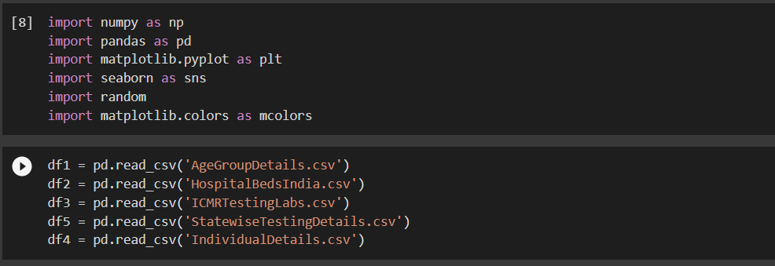

* **Import numpy** : It can be used to perform mathematical operations on arrays such as trigonometric, statistical, and algebraic routines.
* **Import pandas :**  it is used for data wrangling and analysis. It is a convenient wrapper around numpy.
* **import seaborn :** it is a visualization library based on matplotlib. It provides a high leve interface for drawing attractive and informative statistical graphics.
* **import matplotlib :** it is a plotting library which gives inline plots for quick data analysis.
* **read_csv() :** Data from a data file in the project directory is moved into a pandas dataframe. We can optionally specify the column names.

**2: AGE ANALYSIS:**

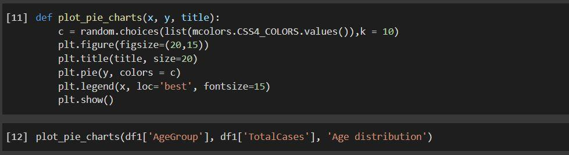

Creating a function to plot pie charts and plotting a pie chart of the age distribution of the confirmed cases.

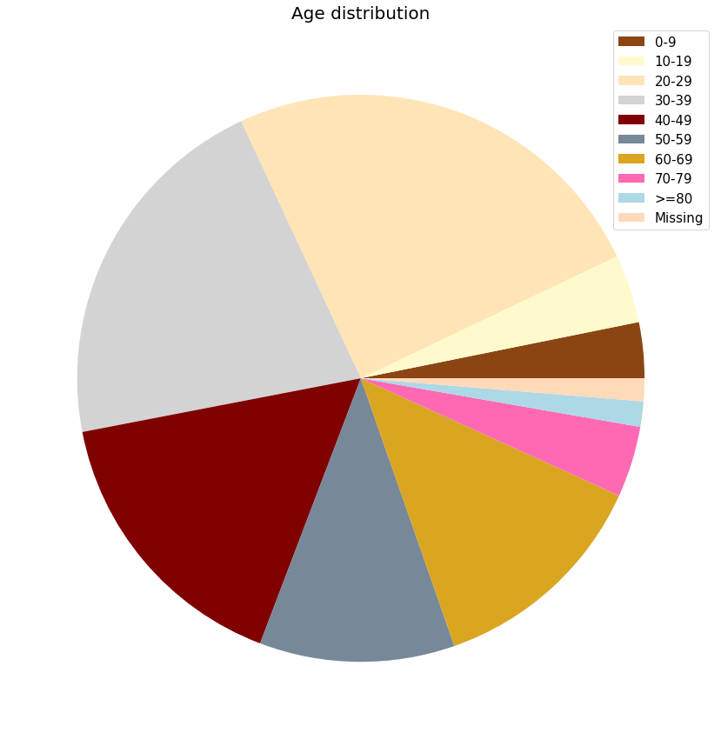

**Observation :** We can see that most of the cases are of people 20-29 age range with the ranges 30-39,40-49,50-59,60-69 also having a high number of cases.

**3. Analysis of number of public health facilities and number of beds:**

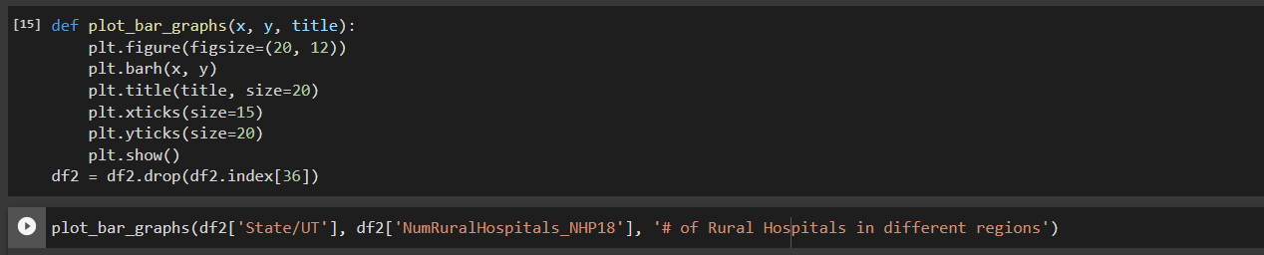

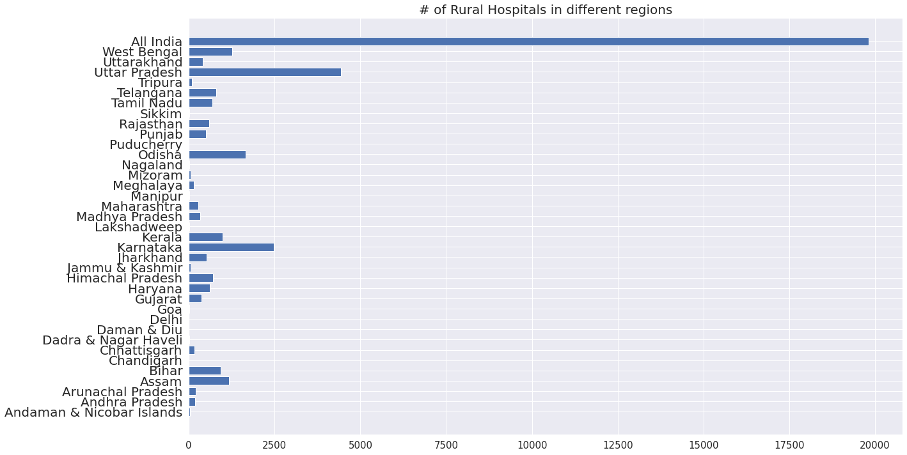

**Observation :**

* Uttar pradesh has the most and is the only state with over 4000 rural hospitals.
* Next followed by Karnataka with 2500 rural hospital and stands at second place.



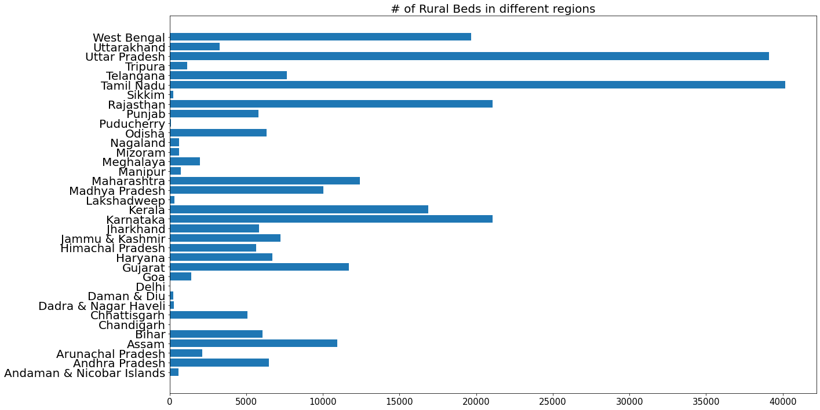

**Observation :**

* Tamil Nadu is the state with the most Beds in the rural areas with over 40000 beds.
* Uttar Pradesh is a close second.
* Karnataka, Rajasthan and west Bengal are having more than 20000 beds and stands in third position.



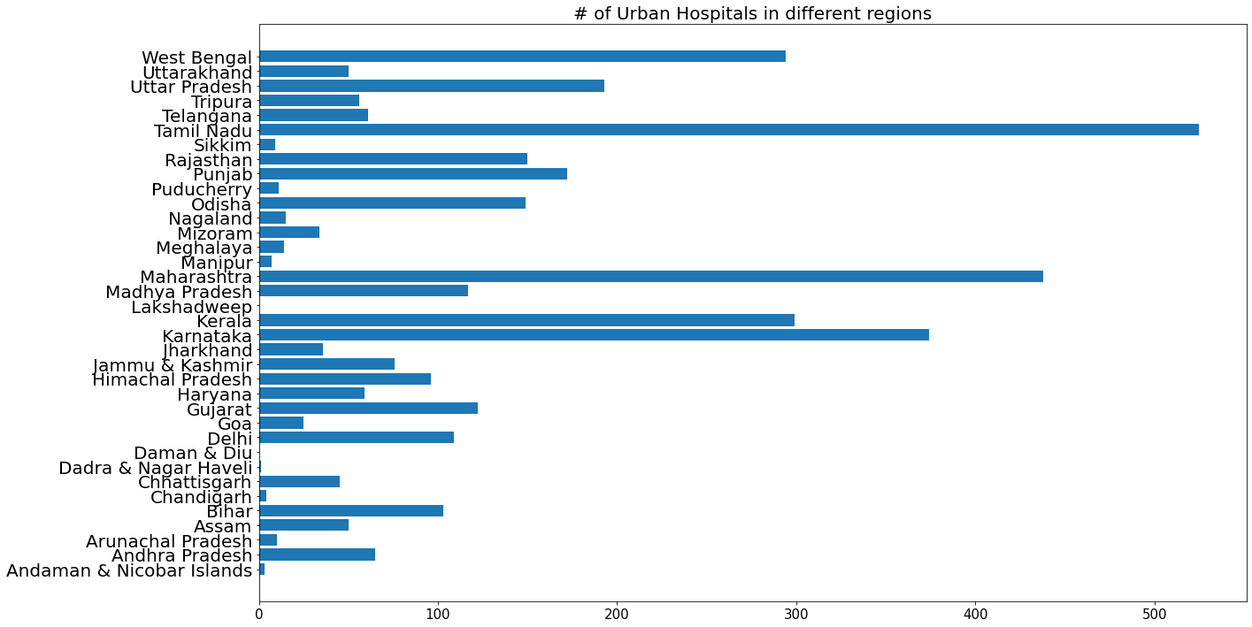

**Observation :**

* Tamil Nadu has the most urban hospitals with over 500 of them.
* Maharashtra is the only other state with over 400 urban hospitals followed by Karnataka with with nearly 400 urban hospitals.



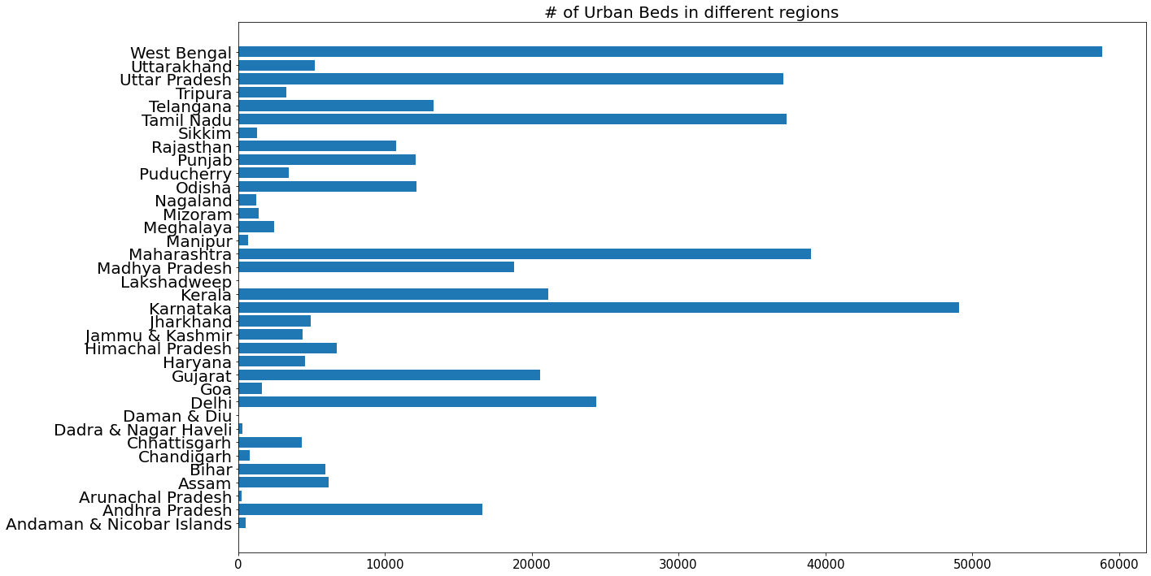

**Observation :**

* West Bengal has the most beds in Urban areas with almost 60000 beds.
* Karnataka in second place with reaching 50000 beds.
* Thirdly Uttar Pradesh Tamil nadu and Maharashtra with more than 38000 beds



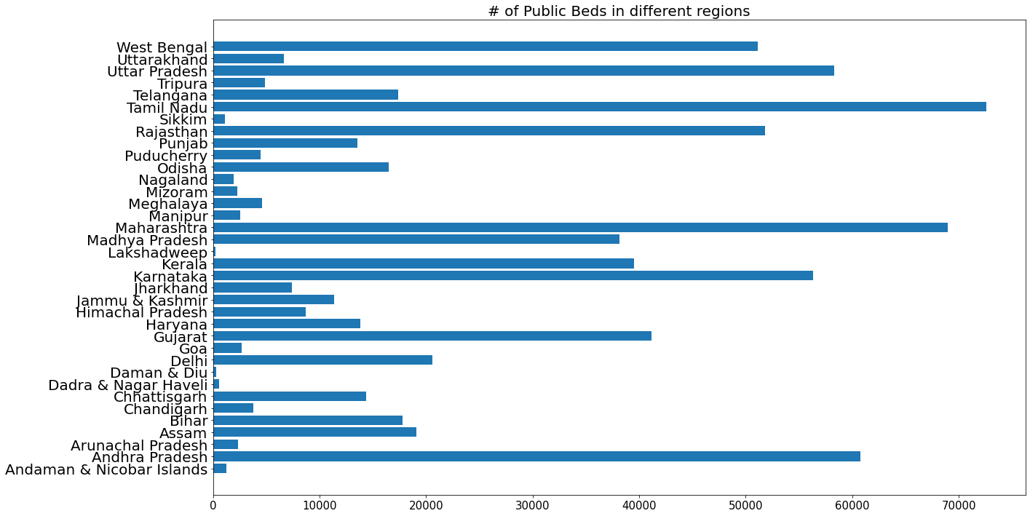

**Observation :**

* Tamil Nadu has the most public beds with over 70000 of them.
* Maharashtra and Andhra Pradesh are the only other state with over 60000 beds.

**4. Analysis of ICMR testing Labs in the country**



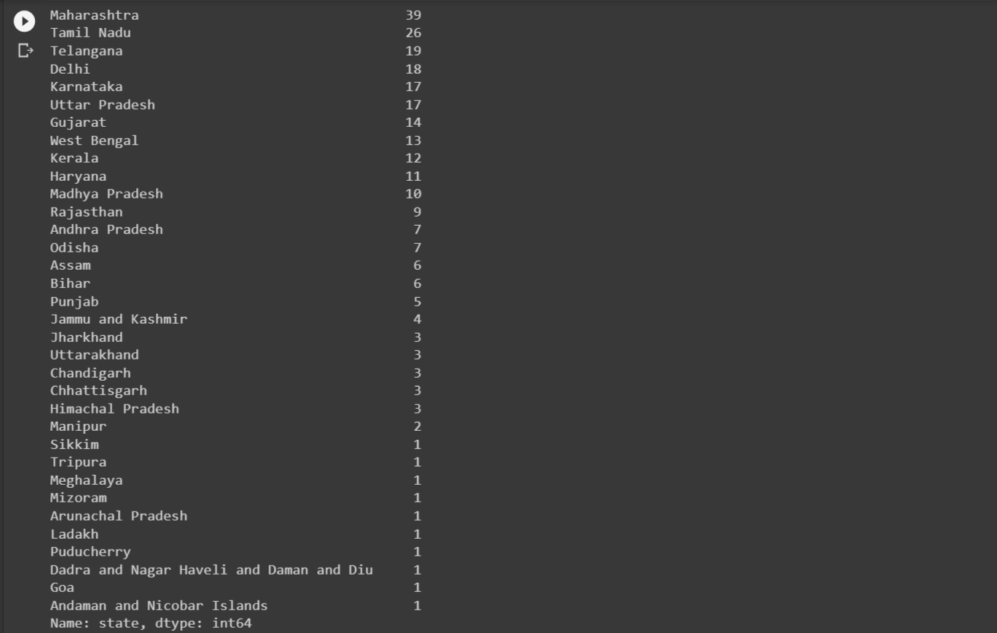



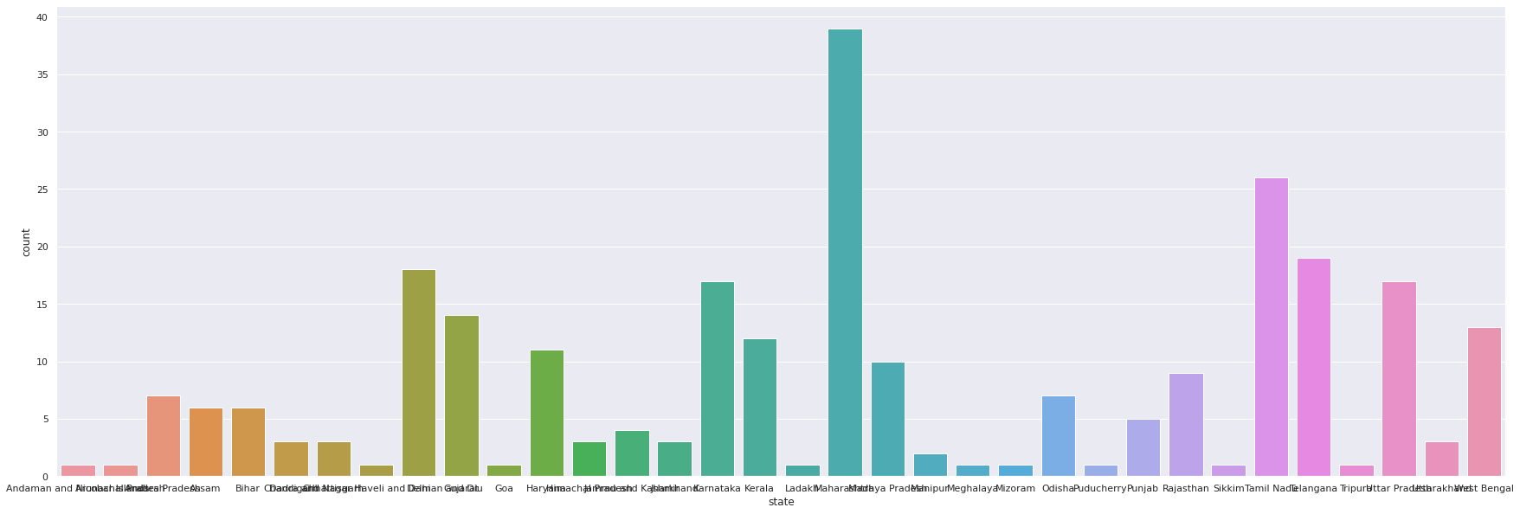

**Observation :** Maharashtra has the most number of ICMR testing labs with 39 of them.

Tamil nadu and Telangana are 2nd and 3rd with 26 and 19 respectively.



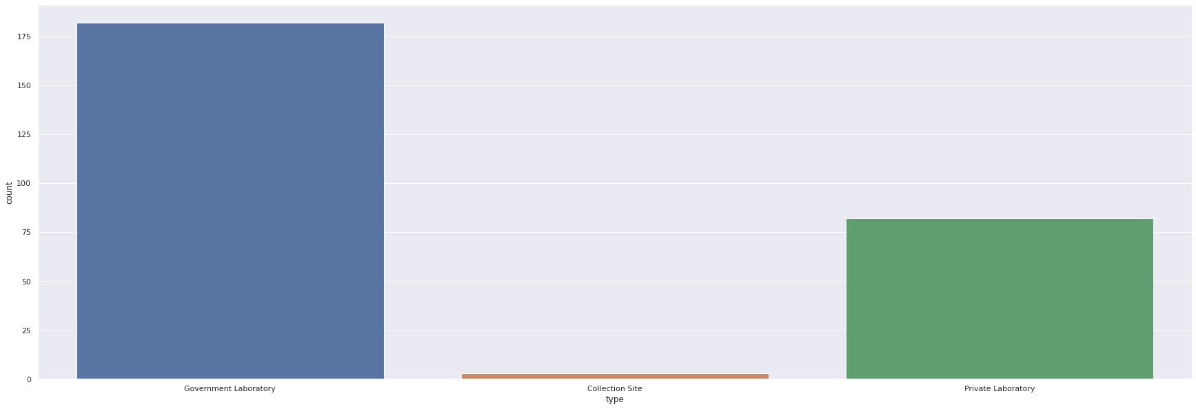

**Observation :** Out of all the ICMR labs, around 180 are Government Labs and around 80 are Private Labs.

**5. Analysis of state-wise Testing details**

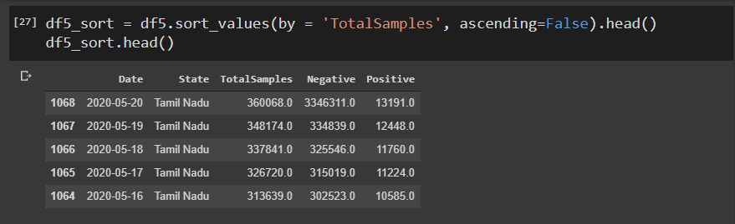

**Observation :** Clearly, Tamil Nadu has the highest number of samples being tested.

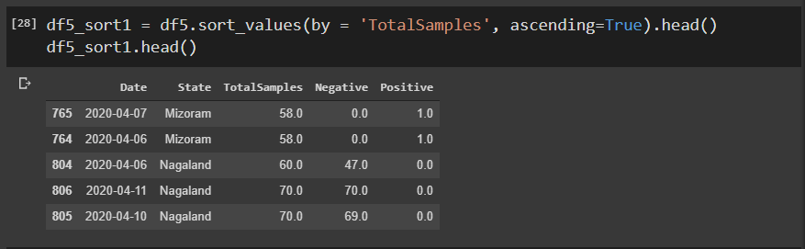

**Observation :** Mizoram and Nagaland have the lowest number of tested samples recorded for a day.

**6. Analysis based on Gender, districts, States and number of Active cases** :

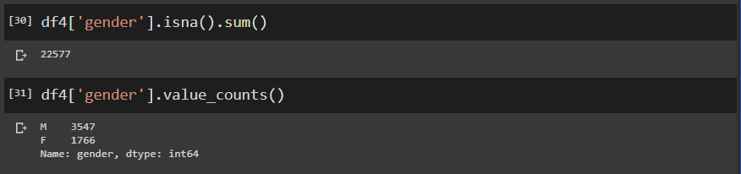



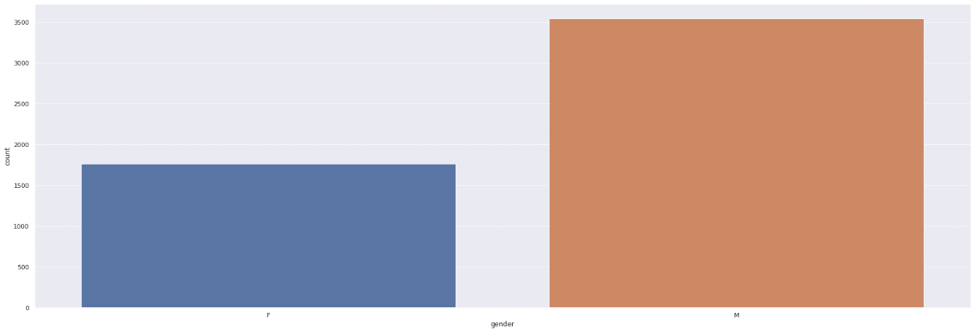

**Observation :** Out of the registered gender entries, patients are 2x as likely to be males than females.

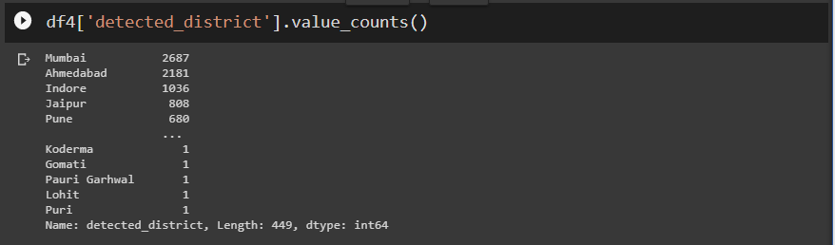

**Observation :** Majority of the cases have been detected in Mumbai when it is seen district wise.



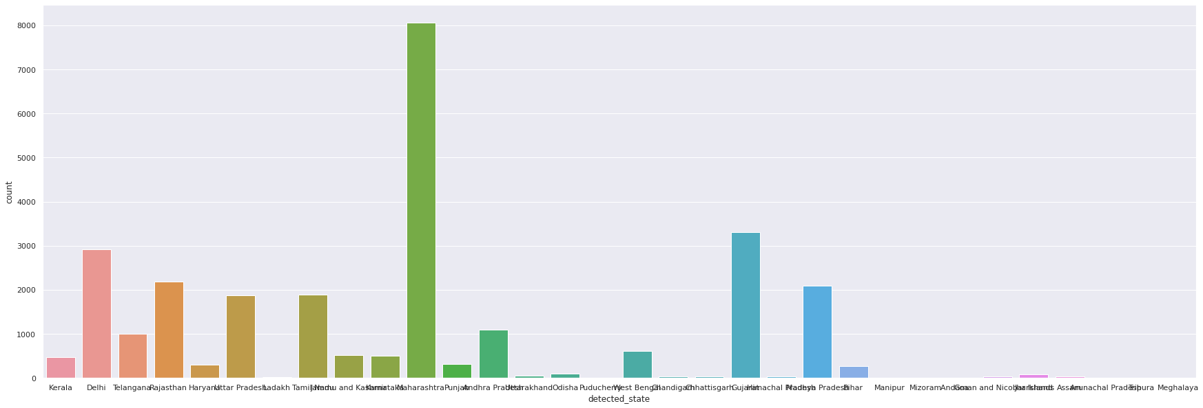

**Observation :** Most cases have been detected in the state of Maharashtra when seen in state wise analysis.



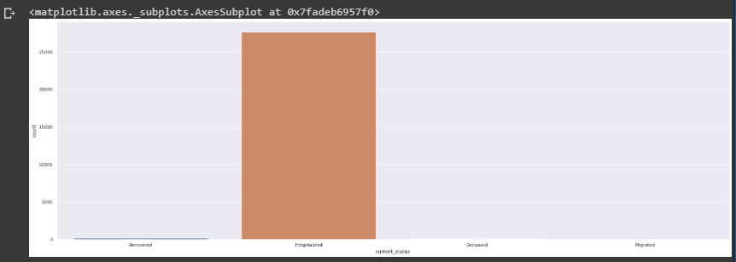

**Observation :** Most of the cases are still active with a small percentage having recovered, deceased or migrated

# LINK TO THE CODE AND DATASET

**GOOGLE COLAB:**

[https://colab.research.google.com/drive/1Kd3sT3HxjoTFarEbBDSnLRwUa51s6Sxx?usp=sharing](https://colab.research.google.com/drive/1Kd3sT3HxjoTFarEbBDSnLRwUa51s6Sxx?usp=sharing%20)

**ON GITHUB:**

<https://github.com/Vidyapro/Predictive-Analysis-ML>

**Project 5: Covid-19 India Analysis**

**By: Vidyashree M S**

**Intern at Utkarshini Edutech**

**________________________________________________________**